|  |  |
| --- | --- |
| **Business Process:** | **Business Technology Office - SUNTAX** |
| **Tax Type:** | **All** |
| **Activity:** | **Accessing ECO Team Worklist** |
| **Sub-Activity:** | **ZICM_WORKLIST** |

**Purpose/Objective**

GTA’s new Education and Compliance Outreach (ECO) program will be managed and reported from Integrated Compliance Management (ICM). ECO leads will be created and managed using ZICM_WORKLIST. This job aid explains this worklist.

**Steps**

After creating a lead, ECO Caseworkers will access the lead information using transaction ZICM_WORKLIST. This transaction bypasses the Selection Criteria (filter) screen, it is applied in the background, and goes directly to your worklist.

**ZICM_WORKLIST**

Enter ZICM_WORKLIST in the Command field.

Click .

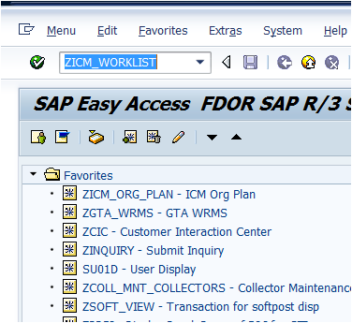

The “ICM Work List – Audit / Campaigns” screen displays.

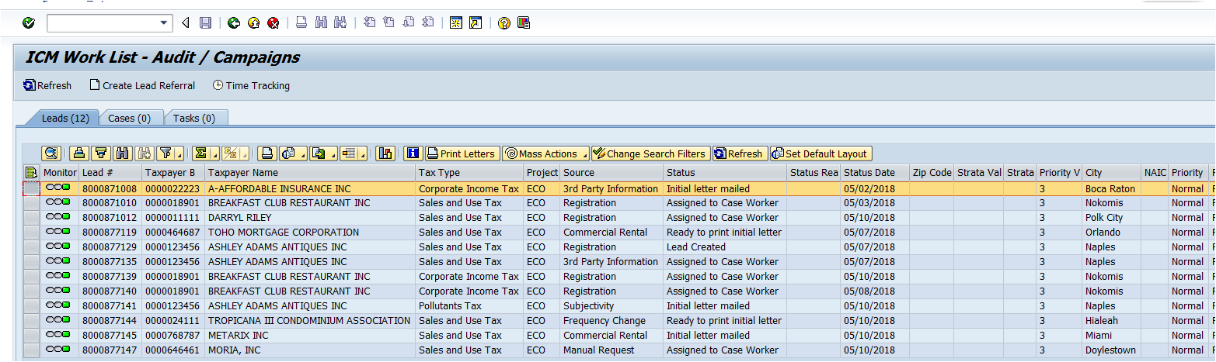

**Worklist Key Buttons**

In addition to the list of leads assigned to the ECO Caseworker, key buttons on the worklist screen assists the caseworker in managing their assigned leads.



* **Print Letters** – This button allows you to print lead letters that are in queue. When a letter has been issued from an ECO lead, you will Save the lead and go back to the worklist to print the letter. After issuing letters on multiple leads, this feature allows you to print all letters that are in queue at one time.

***Note: Currently ECO has one letter – New Registration Letter.***

* **Mass Actions** – Use this button to process a change for multiple leads at one time. For example, Assign/Transfer Leads, Issue Letters, or Close Leads.
* **Change Search Filters** – This button is used to change your filter selections.. When you click this button, the filter screen displays. There are numerous options for searching as shown below.

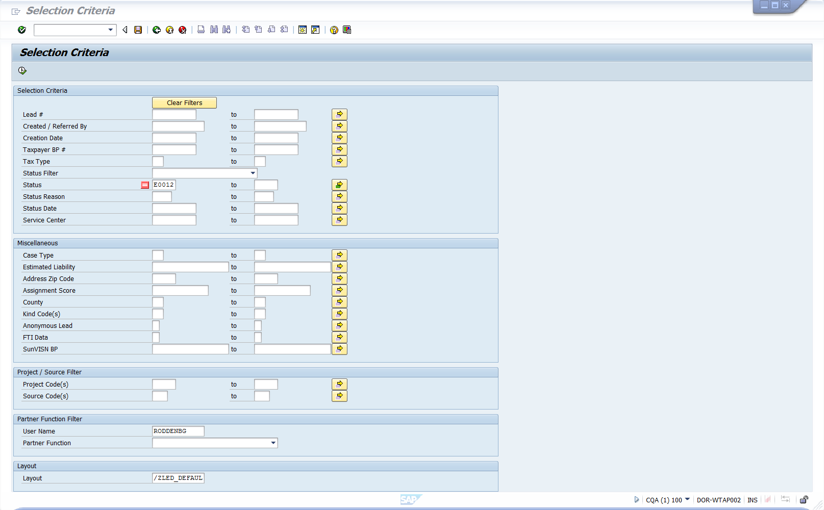

***Note: You can use these filter selections to display a subset of all leads assigned to the caseworker. For example, by filtering on the Status field, you can display only those leads at the selected status.***